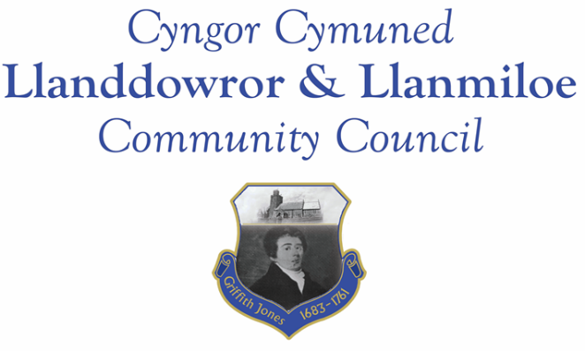

NOTICE OF MEETING

To All Members of Llanddowror & Llanmiloe Community Council.
I hereby summon you to attend a meeting of the Council, to be held by Zoom at 7.00pm on Monday 14th February 2022, for the transaction of the business outlined in the agenda below.

Vicky Mitchell – Clerk

1. Apologies for absence.

2. Declaration of personal interests.

3. Adoption of previous minutes – 10th January 2022.

4. County Councillor’s report, including on matters raised in previous meetings.

5. Clerk’s report giving updates on current matters not currently requiring Council decisions, for information.

6. Matters ongoing from previous minutes requiring discussions or decisions:
- Agricultural Tribunal – receive any update and consider any further related actions.
- Meeting Room car park area - consider offering use by GoSafe

7. New business.
- Consider Clerk salary rate – raised in December meeting.
- Llanmiloe seat – consider purchase for Chris Holt commemorative plaque. Ratify purchase of flowers as a mark of condolence for family.
- Consider donations Council may wish to make this year: requests and suggestions reported to Cllrs prior to meeting.

8. Financial Report
- Current financial situation. Financial report appended to agenda.
- Income received -
- Invoices to pay – Clerk monthly salary and expenses – February.
HMRC monthly payments – February.
Dwr Cymru - £16.50 (direct debit) per month
Swalec - £34.97 – quarterly payment (direct debit)
Chris Thomas – Meeting Room door and water channel - £725.00
Zurich – Council insurance (long-term agreement until March 2023) – £564.25

9. Significant correspondence.
- One Voice Wales training opportunities.
- Buckingham Palace Garden Party.
- ‘Fair election’ pledge for May 2022.

Any other correspondence received prior to meeting but after the date of publication of this agenda will be brought to the attention of the meeting for consideration.

10. Planning matters.

PL/40767 – Phase 2 tourism development of 6 log pods with linked garden enhancements. Land at Llanmiloe House, Llanmiloe. SA33 4TZ Planning decision – full refusal 12-1-22.

PL/033347 - Planning application - Discharge of condition 3 on W/38608 (Archaeological written scheme of investigation). Deers Park Farm, Laugharne, Carmarthen, SA33 4RG. Application registered 20-1-2022. Application granted 2-2-2022

Any planning received prior to meeting but after the date of publication of this agenda will be brought to the attention of the meeting for consideration.

11. Councillors’ reports or items for next meeting.

12. Date of next meeting – 14th March 2022.

~~~~~~~~~~~~~~~~~~~~~~~~~~~~~~~~~~~~~~~~~~~~~~~~~~~~~~~~~~~~~~~~~~~~~~~~~~

