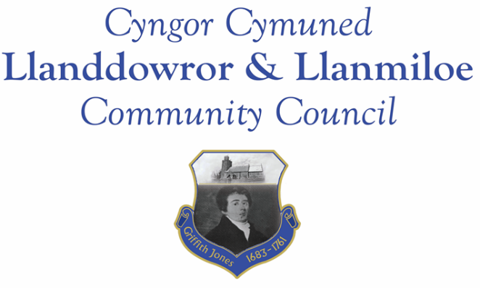
Minutes of the meeting of Llanddowror and Llanmiloe Community Council
Held in Llanddowror Meeting Room, Monday 10th February 2020.

Present: Cllrs Sandra Hewens, Gwyn Owen, Nigel Hodson, David Howells Angela Crewes and County Cllr Jane Tremlett.

- Apologies for absence: Apologies were received from Cllrs Chris Holt, Terence Langdon, Jamie Rugg, Phill Pickersgill.

- To disclose personal and pecuniary interests. No personal interests were declared.

- To review and agree the minutes of the previous meeting on 13th January. These had been previously circulated, and were accepted as a true record by all.

- County Councillor’s report. Cllr Jane Tremlett had circulated the speed monitoring report done in 2018 earlier in the day – it had only been received by her that day. The sleeping policeman in Llanmiloe was being still monitored by CCC, but there was visible deterioration so she had reported it once more to the relevant department. There was also a dip in the road just before it when travelling towards Brook. The kerb by the bus stop in Llanmiloe had had the outer edge tarmaced, but no infill of the gaps between the kerbstones. This would be reported by Cllr Tremlett. The waste bin that was overflowing was still a concern, with rats reported in the vicinity. This would be followed up again by the Clerk. Cllr Tremlett also stated that the responses to the CCC budget consultation had been high at 2000, with 784 responding about the Whitland Recycling Centre.

- Matters ongoing from previous minutes.

- Drainage channel. The contractor would be reminded again about this.
- Knotweed in Llanmiloe. A meeting between the relevant CCC officer and MoD officer had been held to review the locations of the knotweed and start planning the eradication treatment. They noted that a patch adjacent to the highway had been accidentally cut, which was inadvisable – this would be reported to those responsible.

- New business.
- Asset register review. The Clerk had circulated and provided in the meeting copies of the current asset register. This was reviewed in detail, and it was agreed to remove and suitably dispose of items that were no longer used because they were redundant, they were old and unsupported equipment, or they were out of date. The details of these would be retained on the asset register that would be reviewed by the internal auditor for this year. It was also agreed the Clerk should provide options for replacement benches in the villages for the next meeting.
- Footpath diversion proposal. Information on proposed footpath changes in Abercorran and Glancorran were considered, using the maps and description provided by CCC. After discussion it was agreed that the Council had no objections to the proposals.
- CCC deposit consultation for the Local Development Plan. This was discussed, and it was agreed that the Clerk should reply on behalf of the Council that improvement of the sewerage system in Llanmiloe should be made a precondition of any planning consents given, to prevent any problems arising in the future.

- Financial matters.
The current and predicted financial situation for the Council had been previously circulated and copies provided in the meeting. This was reviewed in detail. The Clerk stated that the bank mandate change was still being processed.

Invoices presented for payment: Clerk salary and expenses for February
Clerk tax for February
Dwr Cymru direct debit for February - £9.50
Swalec direct debit for quarter - £62.37
Insurance renewal – (long term agreement) - £983.26
Wales Audit Office – external audit for 2018-19 - £324.75

These invoices were all accepted for payment. Notification about the renewal of the One Voice Wales subscription had been received – the Clerk would forward information on them to all.
Note: - prior to payment of the insurance renewal premium, more competitive quotes were received. The Clerk consulted all Councillors on this and followed their stated wishes. This to be ratified in March meeting.

- Correspondence:
- Thank you letter from the annual CCC Toybox appeal.

- Planning matters:

No applications had been received for consideration.

- Councillor’s reports and information for next meeting:

Cllr Hodson stated that the road that he had reported last month had been patched soon after the meeting. He asked whether there was an obligation for water running off the public highway to be taken onto private land – the Clerk would enquire on this and report back.

There was a query about the status of one planning application – clarification had been requested on whether lodges or caravans had been agreed. The Clerk would chase up for a reply on this.

The Clerk was asked to follow up on the situation with the pumping station in Llanddowror.

Concern was raised about blue bags that had blown into the pills in Llanmiloe.

- Date and venue of next meeting. This was agreed to be Llanmiloe Resource Centre on Monday 9th March , starting at 7.00pm. It was also agreed to move the April meeting to Tuesday 14th April to avoid Easter Monday.

There being no further business, the meeting closed at 8.25pm.

