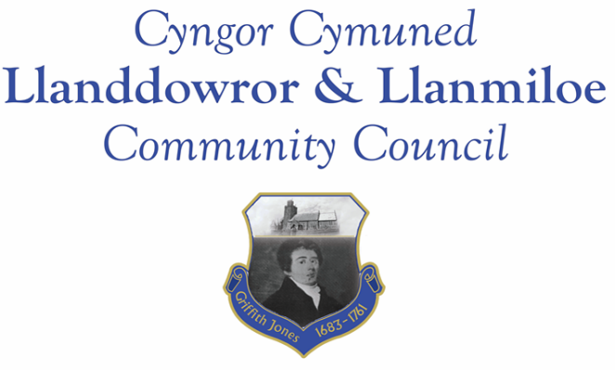
Minutes of the normal meeting of Llanddowror and Llanmiloe Community Council
Held in the various locations via Zoom, Monday 14th December 2020.

Present Cllrs Terence Langdon, Gwyn Owen, Chris Holt, Sandra Hewens, Nigel Hodson, David Howells.
Apologies. These were received from Cllr Phill Pickersgill and County Cllr Jane Tremlett.
Declarations of personal interests. There were no interests declared.
Adoption of previous minutes. The minutes of the meeting of 16th November had been previously circulated. The minutes were accepted as a true record and would be duly signed at the earliest opportunity – proposed Cllr Howells, seconded Cllr Holt and agreed by all.
County Cllr’s report. No report had been received from County Cllr Tremlett by the time of the meeting.
Cllr Hodson joined the meeting at this point.
Matters ongoing from previous minutes:
- Meeting Room water channel. The contractor had been contracted several times over the preceding month, and again stated it would be done very soon - the Clerk would continue to chase to get the work done.
- Councillor vacancies. Several individuals were said to be potentially interested – they would be asked to contact the Clerk for further information.
- Llanddowror bottle bank trial. This had not been put in place. The Clerk was asked to query it with County Cllr Jane Tremlett.
- Community activities by the Council. The Clerk reported that the seats for Llanddowror Pocket Park had been delivered and were very much appreciated. The purchasing and placing of three seats to be donated to LDCA for the playing field was agreed – the Clerk would order these as soon as possible.
New business:
- External Audit for 2019-20. This had been completed and received at the end of October. The Council had received an unqualified audit and there were no issues raised. The Council were pleased to acknowledge this.
- Budget for 2021-22 and precept. This had been circulated before the meeting for Cllrs to examine in detail. Clarification on some of the information was provided, and the figures were discussed. It was agreed by all that the budget as suggested matched the Council’s requirements for the coming year. The Council then unanimously agreed the precept to request from Carmarthenshire County Council.
Financial report:
An up to date report on the finances of the Council had been previously circulated, and was accepted as accurate.
The following invoices were noted, and agreed for payment – proposed by Cllr Howells, seconded by Cllr Hewens and agreed by all:
- Clerk monthly salary and expenses.
- Clerk monthly tax payment.
- Dwr Cymru direct debit £13.50 monthly
- Danfo – toilet cleaning contract - £84.00 for November
- Marmax – seats for Llanddowror - £1130.40
Correspondence
Items of correspondence since the last meeting had been forwarded upon receipt. Specific items to note were:
- One Voice Wales remote training opportunities in December.
- St Clears Railway Station information.
Planning matters:
PL/00810. Two storey side extension. Halldown Farm, Cross Inn. SA33 4QS. Application submitted 18-11-20. There were no objections.

PL/00253. Proposed extension and detached double garage. Maelor House, Llanddowror. SA33
4HH. There were no objections.

W/40767 – wigwams/pods Llanmiloe House garden. This is a revised application so a re-consultation. The Council confirmed that they were against the development at this site for the reasons previously stated. The Clerk was asked to send a letter to CCC to that effect.

W/37321. Outline planning permission for 4 plots and general parking. Land adjacent Dukes Meadow/Wood End, Llanmiloe SA33 4UG. Outline permission granted 17-11-2020. The Council were not pleased that this had been granted despite the serious concerns regarding sewage capacity and flooding in the area that had been raised in 2018 with the application, and the current flooding in that area over the weekend and earlier in the year. The Clerk was asked to contact the Planning Department about this, as well as County Cllr Jane Tremlett, Simon Hart and Angela Burns to convey the Council’s concerns.

PL/00339 Single storey front elevation – 52 Llanmiloe Estate. Granted 17-11-2020.

Councillors’ reports for next meeting.
Cllr Howells stated that the surface water drains throughout Llanddowror were silted up so the roads were running with water – the Clerk would request CCC send out a team to clear them.
Cllr Howells also raised resident queries about speed reduction methods through Llanddowror– a yellow box speed camera or a matrix warning sign. The Clerk would investigate what was possible and report back.
Cllr Hewens stated that a sleeping policeman hump near the school turn off would reduce the danger on that stretch of road. There had been an accident last year involving a speeding car and someone turning right into the school road. The Clerk would investigate what was possible and report back.
Cllr Hewens also stated that a local resident appreciated the support provided by the Council over the last few months. The Council were pleased they could help.
It was also stated that applications were open for the Parc Cynog community grant scheme, with forms available online and in local shops.
Date and venue of next meeting
The next meeting was planned for 11th January 2021, most probably via Zoom. The Clerk would call a meeting beforehand if it was required.
There being no further business the meeting concluded at 8.15pm.

