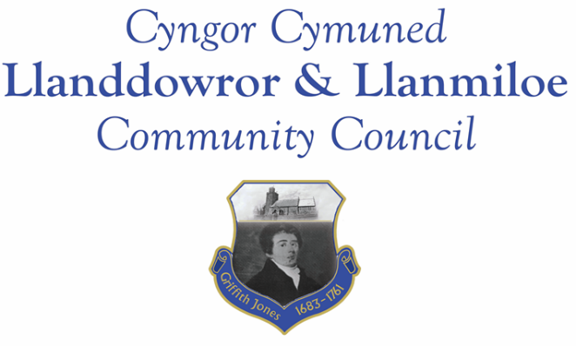

Minutes of the normal meeting of Llanddowror and Llanmiloe Community Council
Held Monday 13th March 2023.

Present Cllrs Sandra Hewens (meeting Chairman), Terence Langdon, Phill Pickersgill, David Howells, Leigh Clarkson, Eric Haines, Gwyn Owen, County Cllr Jane Tremlett, plus 2 members of the public.
- Apologies. There were apologies received from Nigel Hodson.
- Declarations of personal interests. No interests were declared.
- Questions from members of the public regarding agenda items. Concerns were raised about the hedge removal that had taken place at Llanddowror meadows. The Clerk stated she had contacted CCC about this. Any further information would be passed on to them, and the matter chased.
- Adoption of previous minutes for the normal meeting on 13th February 2023. These were agreed by all, and duly signed by the Chairman.
- County Councillor’s report: County Cllr Tremlett had intended to provide an update from CCC officers regarding the 20mph-related plans for Llanddowror, but lack of internet meant this was not possible. She would forward to all as soon as she was able. She agreed to chase up on the sandbag and gritbin provision.
She provided background information as to why ‘Brandy Hill Road’ was so marked on Google maps. She was asked whether the enforcement process could be accelerated now a planning decision had been made – she would ask. The unsightly uneven garden ends at Dan y Bryn was raised – she stated she would ask planning whether there were any conditions imposed to regulate this. A concern was also raised regarding food waste collections – bags were being split by staff during the picking up process and the mess left for residents to clear up. She would raise this with the relevant department. Two queries on public footpaths and accessibility were raised, with members of the public asking that they were cleared so that they could be used. A query was raised as to the tenancy of one social housing property in Llanddowror after its recent renovation.
There being no further queries raised, Cllr Tremlett left the meeting.
- Clerk’s report. The Clerk had previously circulated the report and provided verbal updates on the various matters. The large wall built for one property in Dan y Bryn had been reported to planning because it appeared to have been erected without planning approval. She stated she would chase up on ongoing matters.
- Matters ongoing from previous minutes:
- Community projects: The bids for play equipment had been considered by the Wind Farm, and the outcomes were due to be sent to the two village associations. LCDA had requested that the match funding from this Council be provided because work of necessity had begun – it was agreed to provide the full amount of £3500 to them in this meeting.
- Llanddowror Old Café site. The planning application had been refused, and the case reverted to planning enforcement. The process and associated timescales had been made known to the Council.
- Meeting Room toilets – donations box. The box was now up. It was agreed that the Clerk and Cllr Clarkson should hold the keys and periodically empty the box.
- Donation to Llanmiloe School PTA – the goalposts had been already purchased. Further donation requests from them might be considered in the April meeting.
- New business:
- Meeting Room parking area. The Clerk had circulated a report on potential bollards for the location. It was agreed to remove all the existing bollards (with the assistance of the Village Association) and so provide four parking spaces for Meeting Room users.
- One Voice Wales membership. It was agreed to renew this for another year.
- IRPW 2023-24 report. The Clerk had circulated a report on this, which was summarised for the meeting. It was agreed that, should any Cllr wish to take their mandatory office consumables allowance, it should be done by providing receipts to the Clerk for reimbursement.
- Llanddowror – hedge removal. This had been discussed earlier in the meeting.
9. Financial Report
The current financial situation was provided to all Cllrs.
- Income received: £100.00 from Barclays as an apology for poor service.
- Invoices to pay:
- Clerk monthly salary and expenses – March.
- BLC – toilet cleaning March - £80.00.
- HMRC monthly payments – March.
- Dwr Cymru - £20.50 (direct debit) per month.
- One Voice Wales membership as agreed earlier in the meeting - £148.00
- LCDA donation as agreed earlier in the meeting - £3500.00
- CCC – election May 2022 recharge invoice - £323.32

10. Significant correspondence.
- One Voice Wales training opportunities. These were noted.
- Carmarthenshire County Council – countywide community review. This was noted.
- Llanddowror road closure for 3 days starting 3rd April. This was noted.

11. Planning matters.
Pl/05469 – Erection of ground maintenance and machinery storage shed (in retrospect) Land east of Llanmiloe House, Llanmiloe. Application registered 22-02-2023. Concerns were expressed that this erection had led to the increased flooding issues on the land, footpath and roadways below it – it was noted a water course ran directly adjacent to the shed location.

PL/05154 – Retrospective change of use of a café cark park to an enclosed yard to house rescue dogs including the retentin of storage containers and a 2.1m high security fence. Dany y Pound Cottage, Llanddowror. Application registered 13-12-2022. Duill refusal decision – 17-02-2023.
12. Councillors’ reports for information or items for next meeting.
It was suggested that replacement noticeboards for both Llanmiloe and Llanddowror beconsidered in the coming financial year.
The ownership of the planters on the Meeting Room patio area were clarified. It was stated that there were a number of jobs going in the new Pendine Attractor facility, including hospitality ones. The Clerk was asked to do a poster to advertise the vacancies in the South Ward.
13. Date of next meeting – 17th April 2023.
There being no further business the meeting concluded at 8.40pm

