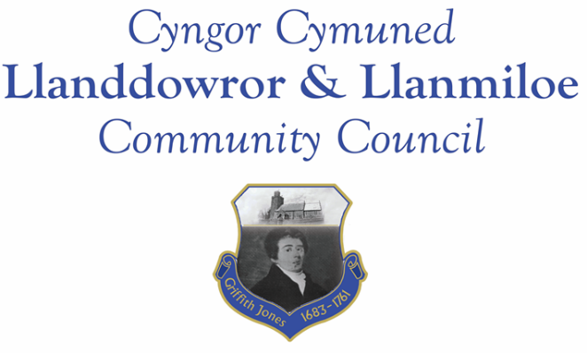
Minutes of the annual meeting of Llanddowror and Llanmiloe Community Council
Held in the various locations via Zoom, Monday 8th June 2020.
Present Cllr Phill Pickersgill in the chair, Cllrs Sandra Hewens, Chris Holt, Nigel Hodson, Gwyn Owen, Terence Langdon, David Howells.
Cllr Phill Pickersgill welcomed everyone to the meeting.
1. Apologies for absence were received from Cllrs Angela Crewes, Jamie Rugg and County Cllr Jane Tremlett. The reasons for their absence were accepted.
2. Declarations of personal interests. There were none received.
3. Address by outgoing Chairman. Cllr Pickersgill stated that he had been very grateful for the backing of his fellow Cllrs during the year and also expressed his thanks to the Clerk for her work. He stated that he felt all members of the Council were very supportive of one another, and even when there were differing opinions they came to a compromise acceptable to all without conflict. He wished his successor all the best for the coming year.
4. Election and installation of new Chairman and Vice-Chairman for 2020-21. After a brief discussion it was unanimously agreed to elect Cllr Langdon as the Chairman for the year. Proposed by Cllr Howells, seconded by Cllr Hewens and agreed by all. The position of Vice-Chairman was then considered, and after discussion it was agreed to delay the decision on this for the next in-person meeting in September if that were possible.
5. Review of internally audited accounts, internal auditor report, financial governance statements. These had been previously circulated. These were all agreed as acceptable and correct by those present – proposed Cllr Howells, seconded Cllr Holt. The Clerk would contact the Chairman directly regarding signing them off prior to documentation being sent to the external auditor.
6. Adoption of policies of the Council. The various policies and documents that regulated the Council’s work were considered and adopted for another year: Code of Conduct; Standing Orders; Financial Regulations; Financial Risk Assessment; Welsh language policy; Complaints policy; Reserves policy; Equal opportunities policy; Dignity bullying and harassment policy; Election and co-option policy.
There being no other business, this meeting closed.

