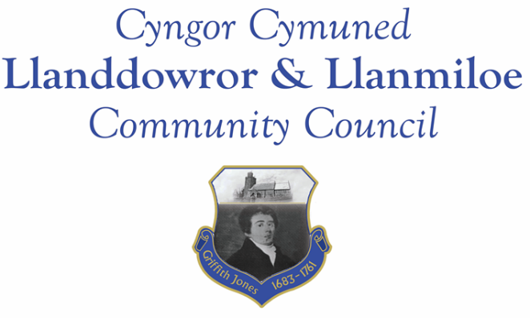
Minutes of the annual meeting of Llanddowror and Llanmiloe Community Council
Held on Monday 15th May 2023.

Present: Cllrs, Sandra Hewens, David Howells, Gwyn Owen, Eric Haines, Nigel Hodson, Leigh Clarkson and 1 member of the public.
- Election and installation of new Chairman. Nominations for the role of Chairman were sought, and after discussion Cllr Haines was proposed by Cllr Owens, and seconded by Cllr Howells. All expressed their verbal agreement, and so Cllr Haines was elected as Chairman for the year. He duly signed her declaration of office. After discussion Cllr Langdon was then nominated for role of Vice-Chairman, with this to be confirmed in the June meeting.
- Apologies. These were received from Phill Pickersgill and Terence Langdon, and accepted.
- No personal or prejudicial interests were declared in the items listed on the agenda.
- Address by outgoing Chairman. Cllr Hewens read out a short statement reviewing her year of office, detailing how proud she was to have been a Community Councillor for twenty years, and to have been Chairman once more this last year. She stated that the community needed good Councillors, as they had, supported by their knowledgeable and hardworking Clerk. She referenced the work done in the community, and the wider events of her year, including the loss of Queen Elizabeth II and the accession of King Charles III. Finally she expressed her thanks to all the Council for their support and work. His comments were supported and appreciated by those present.
- Review of annual accounts for 2022-23; Internal Auditor report; Annual Return governance statements. These had all been previous circulated, and were also provided for review by those present. The Council agreed to accept the accounts, and were pleased to note that the Internal auditor report had found no issues. The governance statements were reviewed, and it was agreed the Council had complied with them. It was therefore agreed by all that the Chairman should sign the Annual Return, which he did.
- Review and re-adoption of existing policies and other governing documents of the Council: Code of Conduct; Standing Orders; Financial Regulation; Financial Risk Assessment; and Policies for Welsh; Complaints; Reserves; Equal Opportunities; Dignity, Bullying and Harassment; Election and Co-option. These were all accepted for another year, after some agreed amendments were made to the Financial Regulations for the Council’s move towards online banking. In addition the updated Biodiversity report, which had been previously circulated, was agreed to by all.
- Consideration of dates for future meetings. The Clerk had compiled a list for the coming year which was discussed and accepted. This list would be placed on the website and noticeboards to inform the public. Meetings would be undertaken in accordance with the current legislation.
There being no further business, the Chairman closed this meeting at 7.20pm.

