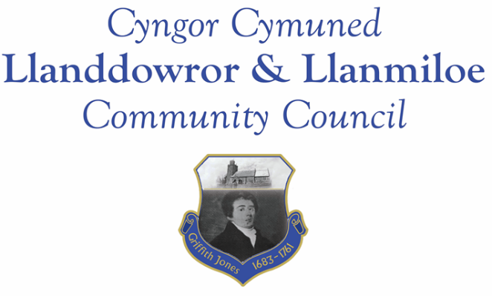

Minutes of the normal meeting of Llanddowror and Llanmiloe Community Council
Held Monday 14th November 2022.

Present Cllrs Sandra Hewens (meeting Chairman), Terence Langdon, Gwyn Owen, David Howells, Eric Haines, Nigel Hodson, Leigh Clarkson and members of the public.
- Apologies. There were apologies received from Cllr Phill Pickerskill and Cllr Tremlett.
- With the agreement of the whole Council the item on Council vacancies was moved up the meeting agenda. A member of the public stated their interest in becoming a community councillor, and after a brief discussion they were voted into the role unanimously and duly signed their declaration. The Council welcomed Leigh Clarkson to the role.
- Declarations of personal interests. Interests were declared by Cllr Haines with regard to a planning matter and Cllr Clarkson with regard to a financial decision.
- Questions from members of the public regarding agenda items. Members of the public raised their ongoing concerns regarding the existing planning enforcement case in Llanddowror and their related concerns regarding speeding traffic through the village. Both items had been previously raised a number of times by the Council with CCC and GoSafe. The concerns were noted.
- Adoption of previous minutes for the normal meeting on 3rd October 2022. These were agreed by all, and duly signed by the Chairman.
- County Councillor’s report: County Cllr Tremlett was not present and had not provided an update for the meeting. The Clerk stated that she had sent a reminder of the request for a site meeting regarding the Llanddowror planning enforcement issue a week prior to the meeting. This issue continued to be a major concern in the village as the public comments at the start of the meeting showed. It was agreed the Clerk should request Cllr Tremlett urgently arrange a site meeting with concerned villagers, Community Cllrs and relevant CCC Officers to get movement towards a resolution for the matter.
No further information had been provided regarding the provision of sandbag containers or sandbags by CCC directly or by Cllr Tremlett to the Council.
- Clerk’s report. The Clerk had previously circulated the report and provided verbal updates on the various matters. She would chase up the various matters with CCC officers.
- Matters ongoing from previous minutes:
- Community projects: the replacement seating had been installed; the Clerk had contacted both community associations and provided information on potential providers of play equipment; the Llanddowror Pocket Park tree management payment was delayed by lack of contact with the contractors currently.
- Llanddowror Old Café site. This had been extensively discussed during the public participation section of the meeting. It was agreed that it was an ongoing concern, with residents feeling increasing disillusioned with the handling of it by CCC. It was in addition stated that the continuously parked vehicles led to an increased flooding risk since the road and drainage system could not be cleaned or maintained properly.
- Council vacancies. This had been covered earlier in the meeting.
- Llanddowror Meeting Room donations box. This was in progress.
- New business:
- Council support for community association grant applications for play equipment. It was agreed that the Council could provide up to £7,000 total match funding to the two village associations to be shared between them as match funding for provision of play equipment this financial year. No commitment to any funding was or could be made for future years.
- Round speed bumps – it was agreed to ask CCC to provide the round speed bumps in both villages if these were proven to reduce speeding issues.
- A477 Llanddowror junction. It was agreed to ask SWTRA to provide street lighting or some suitable alternative illumination at this junction urgently for safety reasons. Currently there was nothing and even local residents could miss the junction when it was dark.

9. Financial Report
The current financial situation was provided to all Cllrs. The recently agreed national pay award due to start 1st April 2022 for the Clerk was noted. It was agreed to refund the Clerk for the laptop purchase as soon as possible after that had happened.
- Income received: No income had been received since the last meeting.
- Invoices to pay:
- Clerk monthly salary and expenses – October and November.
- BLC – toilet cleaning October and November - £64.00, £64.00. Cllr Clarkson declared an interest in this item
- HMRC monthly payments – October and November.
- Dwr Cymru - £20.50 (direct debit) per month.
- Swalec - £41.42 on 31-10-22 – direct debit.

10. Significant correspondence.
- One Voice Wales training opportunities. This was noted.
- Welsh Govt –consultation on the draft legislation affecting second home tax levels. This was noted.
- CCC information on the 20mph consultation. This was noted.

11. Planning matters.
PL/04740 - Siting of a static caravan adjacent to dwelling for use as overflow accommodation for dwelling house known as Cwm Curyll - Cwm Curyll, Brook School Road, Laugharne, Carmarthen, SA33 4NX Application registered 16/10/2022. There were no objections raised so long as this development did not negatively impact the traffic levels using the road.

PL/04886 - Proposed new parking area in Llanmiloe school - Llanmiloe Cp School, Llanmiloe, Carmarthen, SA33 4TU. Application registered 12/10/2022. There were no objections to this.

PL/04972 - Proposed erection of a single new dwelling on an existing and on-going residential development site - Plot 9, land adj to Wood End, Llanmiloe, Pendine, SA33 4EZ. Application registered 1-11-2022. There were no impact so long as this was two storey as a maximum and in keeping with the appearance of other dwellings in the area.

PL/04456 - Proposed erection of a single new dwelling on an existing residential development - Land Adjacent to Wood End/Dukes Meadow, Pendine, Carmarthen, SA33 4UG. Application registered 13-09-2022. Application granted 9-11-22

W/40767 – AP7214 – Phase 2 tourism development for 6 log pods with linked garden enhancements. Planning appeal lodged by applicant with Planning and Environmental Decisions Wales. It was noted that comments already made will be passed to the Planning Inspectorate. Cllr Haines declared a personal interest in this item.

12. Councillors’ reports for information or items for next meeting.
Cllr Howells stated that the kitchen light had been defective, but the Village Associaton had repaired it. The Village Associaton was thanks for this. In addition a tea urn had been provided.
Cllr Hewens stated that he bus stop by the old club was surrounded by sludge and fallen leaves., The Clerk wold report this for cleansing.
13. Date of next meeting – 12th December 2022.
There being no further business the meeting concluded at 8.45pm

