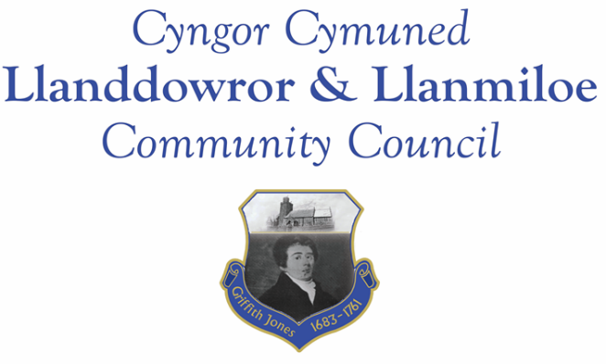

Minutes of the normal meeting of Llanddowror and Llanmiloe Community Council
Held Monday 13th February 2023.

Present Cllrs Sandra Hewens (meeting Chairman), Terence Langdon, Phill Pickersgill, Nigel Hodson, David Howells, Leigh Clarkson, Eric Haines, County Cllr Jane Tremlett.
- Apologies. There were no apologies received.
- Declarations of personal interests. No interests were declared.
- Questions from members of the public regarding agenda items. No questions were raised.
- Adoption of previous minutes for the normal meeting on 9th January 2023. These were agreed by all, and duly signed by the Chairman.
- County Councillor’s report: County Cllr Tremlett provided an update from CCC officers regarding the listing provided in the last meeting to her of traffic management measures in the area. It was stated that the upcoming 20mph project was taking the bulk of the relevant officers’ time, but that they were looking to see what further measures could be taken for Llanddowror. It was anticipated that these plans would be available in early March. The sandbags had not yet been delivered – Cllr Tremlett stated she would chase up on these.
Information on the recent covert speed monitoring was provided in the meeting. The Clerk would following this up with GoSafe. It was also reported by Cllr Tremlett that the Tavernspite road from Llanddowror was now on a gritting route.
- Clerk’s report. The Clerk had previously circulated the report and provided verbal updates on the various matters. Two items (the post box access and the sludge/mud around the bus stop) had been resolved since the last meeting. Other matters she stated she would chase up on.
- Matters ongoing from previous minutes:
- Community projects: The bids for play equipment had been submitted by the two Associations to the windfarm. No decisions had yet been made.
- The tree work had been carried out in Llanddowror Pocket park – the invoice was for payment agreement at this meeting.
- Llanddowror Old Café site. The planning application decision was awaited – the relevant CCC officer had said it should be made this week.
- Meeting Room toilets – donations box. Good progress was being made and this should be available soon.
- Donation to Llanmiloe School PTA – no quotes had been provided for the meeting.
- Meeting Room water leak. The repairs had been made and invoices from contractors supplied for payment agreement at tis meeting. The replacement solenoids for the washer units had been bought and should be installed this week.
- New business:
- It was stated that the April and May meetings were both currently timetabled for Bank Holidays. It was agreed to move both meetings on a week, so they would take place on Monday 17th April and 15th May.
- Llanmiloe School Governor vacancy. The Clerk had been contacted by CCC stating that there was a vacancy – it was noted that it did not have to be filled by a Councillor. It was agreed to inform the Clerk of potential candidates to pass on.
- Change to 20mph speed limits through villages. The Clerk had previously circulated the link for the consultation by CCC on this, and also provided maps of the local areas showing the proposed changes. It was raised as a concern that the speed would be retained as 30mph through Llanmiloe. It was also stated that the Llanddowror 20mph area should extend further westwards to take in the residences that currently exist on the edge of the village.
9. Financial Report
The current financial situation was provided to all Cllrs.
- Income received: £0.00.
- Invoices to pay:
- Clerk monthly salary and expenses – February.
- BLC – toilet cleaning February - £64.00.
- HMRC monthly payments – February.
- Dwr Cymru - £20.50 (direct debit) per month.
- Swalec - £39.56 for the fourth quarter – direct debit.
- Davies Y Gwres - plumbing work - £175.00 – maintenance/MR
- Chris Thomas – repair work - £100.00 – maintenance/MR.
- Wallgate - solenoids - £126.36 – maintenance/MR
- Zurich – insurance - £586.31
- Birch Utility Services – tree work = £540.00 – community project.

10. Significant correspondence.
- One Voice Wales training opportunities.
- Carmarthenshire County Council – advance notice of countywide community review.

11. Planning matters.
Pl/05356 - Lawful development - outbuilding and bedrooms. Picton House Hotel. Llanddowror. SA33 4HJ. Application registered 26-01-2023. There were no objections.

PL/05275 - One Planet Development including workshops, stable and polytunnels - Wij Wood, Four Wheels, St Clears, Carmarthen, SA33 4HD. Application registered 11-01-2023.There was concern expressed about the access onto a fast road with blind points at times – it was considered a potential safety matter.

PL/05405 - Construction of new two level residential dwelling house with loft room and summer house - Plot 6 Dan Y Bryn, Pendine. SA33 4UG. Application registered 9-2-2023. There were no objections.

PL/05396 - Construction of detached garage & equipment store - Cnwc, Llanddowror. SA33 4HN. Application registered 10-2-2023. There were no objections.

PL/04502 - Construction of house - 14 Dan Y Bryn, Pendine, Carmarthen, SA33 4EZ Application registered 12-09-22. Application granted 6-2-2023
PL/04972 - Proposed erection of a single new dwelling on an existing and on-going residential development site - Plot 9, land adj to Wood End, Llanmiloe, Pendine, SA33 4EZ. Application registered 1-11-2022. Application full granted 19-01-2023.

PL/05172 - Proposed erection of a single new dwelling on an existing residential development. Plot 4, Dan Y Bryn, Pendine, SA33 4UG.Application registered 8/12/2022. Application full granted 20-01-2023.

PL/05282 - Conversion of integral garage. Woodside, Brook, Laugharne, Carmarthen, SA33 4NX. Application registered 9-01-2023. CLOPUD approval 20-1-2023.

PL/00027 - Improvement to access and creation of turning and loading area in association with forestry management. Parciau Forestry, Llanddowror. Application valid 11-9-2020. Application full granted 26-01-2023.

PL/05194 – Prior notification – building (agricultural/forestry). Proposed steel frame agricultural building for the storage of implements and machinery. Land adjacent to Morfa Bach Cottage, St Clears, SA33 4HD. Application registered 13-12-2022. Application decision - prior approval required 30/12/2022. Prior approval granted 31-01-2023.

12. Councillors’ reports for information or items for next meeting.
It was stated that the boundary walls for the various properties in the Dan y Bryn development were not aligned. There was concern some were encroaching upon Carmarthenshire County Council’s land. The Clerk would raise this with CCC.
It was agreed that potential speakers for both a potential site review and potential planning committee should be discussed and agreed locally as soon as possible.
Concern regarding parking that was restricting causing issues and safety concern was again raised for the junction in Llanddowror. The Clerk would send a letter to those concerned.
The Clerk was asked to review the Coastal pathway with Cllr Hewens regarding various concerns.
13. Date of next meeting – 13th March 2023.
There being no further business the meeting concluded at 8.40pm

