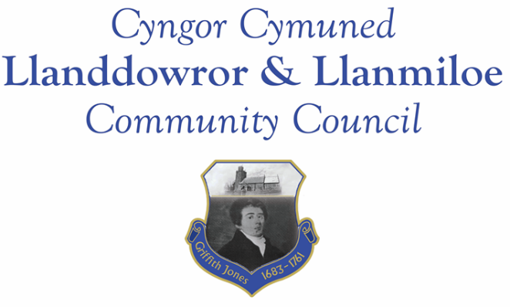
Minutes of the normal meeting of Llanddowror and Llanmiloe Community Council
Held in the various locations via Zoom, Monday 13th September 2021.

Present: Cllrs, David Howells (Chairman), Terence Langdon, Nigel Hodson, Gwyn Owen, Sandra Hewens and County Cllr Jane Tremlett.
Apologies. These were received from Cllr. Catrin Davies and were accepted.
Declarations of personal interests. No interests were declared.
Adoption of previous minutes. The minutes of the meeting of 14th June 2021 had been previously circulated. The minutes were reviewed and accepted as a true record and would be duly signed at the earliest opportunity – proposed Cllr Langdon, seconded Cllr Owen and agreed by all.
County Cllr’s report. Cllr Jane Tremlett provided a brief update on the social and domiciliary care employment measures that were being taken by Carmarthenshire County Council in view of the current number of unfilled vacancies. She highlighted the current well-being consultation that was available – the Clerk would forward the direct link to all Councillors for their information.
A query was raised on the Llanmiloe flooding report that had been sent to CCC several months back. Cllr Tremlett would seek an update as to any actions that were planned or being taken, and report back to the Council.
A query was raised about the Llanddowror speeding, and monitoring visits by GoSafe. The Clerk would contact them for an update and pass on the information to the Council.
A query was raised about the placing of picket-gate entrances to the villages, as is done elsewhere in West and Mid Wales and throughout the UK – what would CCC’s position be on the placing of these by either LLCC or the local Village Association? A related query on the provision of flashing road speed signs was also raised – again, if funded not by CCC, could they be put in place? Cllr Tremlett would investigate and report back.
A query was raised about ongoing periodic vandalism and arson in Llanmiloe and Pendine – the perpetrators were known to the police, but the incidents appeared to be escalating. Cllr Tremlett would ensure the police knew and that she was provided with updates.
A query was raised about the parking situation through the summer, with visitors parking along the main road because of insufficient parking space elsewhere and the Pendine Attractor project being delayed. It was stated that the reduced visibility led to an increased risk of accidents. Cllr Tremlett stated that a new contractor had been appointed and work had restarted.
There being no further matters to raise with Cllr Tremlett, she then left the meeting. It was agreed that any issues to raise with Cllr Tremlett from the rest of the meeting would be passed on by the Clerk.
Matters ongoing from previous minutes:
- Meeting Room water channel. The Clerk had not received a reply from the appointed contractor. Further attempts would be made to contact him and clarify the situation, both about the water channel and providing advice on the replacement of the Meeting Room door.
- Councillor vacancies. There was to be an item in the Llanddowror Village newsletter to raise awareness of these in the next few weeks.
- Flooding in Llanmiloe. The Clerk had circulated a map showing land ownership and responsibility prior to the meeting, and provided it onscreen during this item. It was stated that because water was unable to drain away correctly it was having a deleterious impact upon the land – good pasture or cropping land was becoming sodden and marshy, severely reducing its value and usability. The Clerk would highlight this in her ongoing correspondence with MoD, Qinetiq and others.
- Llanddowror Meeting Room door – this had been covered in an earlier item.

New business:
- Biodiversity policy and plan. This had been previously circulated, and was reviewed and some amendments made. It was then re-adopted by the Council.
Cllrs Hewens and Owen then left the meeting and were unable to re-join for technical reasons. The meeting thus becoming inquorate, the following items were looked at from an information viewpoint, with no Council decisions being made.
- Llanddowror – slurry tanker movements and potential road and bridge damage. This had been raised during the summer. The Clerk had contacted CCC regarding both potential damage issues and would follow up the queries and report back.
- Carmarthenshire Antiquarian Society – Enlightenment project. This was noted.
- Llanmiloe noticeboard – this would be looked at and information brought back to the Council regarding repair.
- Dog fouling – this had been raised as an issue during the summer. The Clerk had obtained some signs to go on CCC street furniture that would be passed on.

Financial report:
An up to date report on the finances of the Council had been previously circulated. It was suggested that next month it be considered whether money from the reserves be reallocated into the street-lighting budget because late presentation of the 2020-21 payment had resulted in it coming out of this year’s budget.
The following invoices were noted as all contractual, and so acceptable for payment:
- Clerk monthly salary and expenses for July, August, September.
- Clerk monthly tax payment for July, August, September.
- Dwr Cymru direct debit £13.50 monthly.
- Danfo – toilet cleaning contract - £105.00 for June; £84.00 for July; £105.00 for August.

Correspondence
Items of correspondence since the last meeting had been forwarded upon receipt. Specific items to note included:
- One Voice Wales remote training opportunities each month. These were noted.
- CCC consultation on 10 year housing and regneration masterpaln – closed July 26th 2021. This was noted.
- CCC waste collection strategy consultation – closed July 7th 2021. This was noted.
- Welsh Water sewer work in Llanddowror between July and October. It was stated that the work was being done with excellent communication from the company. The Clerk would send a letter of thanks.
- Boundary Comission for Wales final recommendations report. This was noted.
- Welsh Government consultation on changes to election procedures at County and Community level – closing date 24th September 2021. This was noted.

Planning matters:
There were no new planning applications to consider. The completed applications reported to the meeting were:

PL/02422. Land at West Marsh Farm. Prior notification for an agricultural/forerstry building – namely a polytunnel. Decision made by CCC 1-9-2021 that prior approval was not required.

It was noted that a pre-planning consultation for Deers Park Farm in Laugharne had been circulated in August, but the full planning application had not yet been submitted for consultation.

Councillors’ reports for next meeting.
There were no reports or matters put forward for the next meeting that had not been previously mentioned.
Date and venue of next meeting
The next meeting was scheduled for 11th October 2021, either by Zoom or in Llanmiloe Resource Centre. The Clerk would call a meeting beforehand if it was required.
There being no further business the meeting concluded at 8.15pm.

