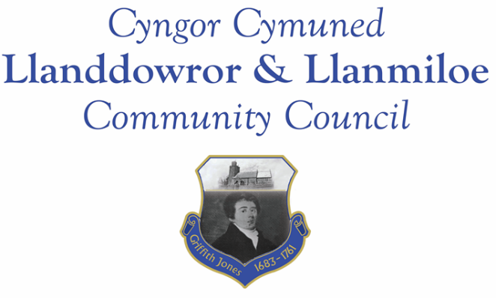
Minutes of the annual meeting of Llanddowror and Llanmiloe Community Council
Held on Monday 9th May 2022.

Councillors signed their declarations of acceptance of office before the meeting started.
Present: Cllrs Terence Langdon, Sandra Hewens, David Howells, Gwyn Owen.
- Election and installation of new Chairman. Nominations for the role of Chairman were sought, and after discussion Cllr Hewens was proposed by Cllr Owens, and seconded by Cllr Howells. All expressed their verbal agreement, and so Cllr Hewens was elected as Chairman for the year. She duly signed her declaration of office. After discussion Cllr Langdon was then nominated for role of Vice-Chairman, and duly signed his declaration of office.
- Apologies. These were received from Phill Pickersgill and Eric Haines, and accepted.
- No personal or prejudicial interests were declared in the items listed on the agenda.
- Address by outgoing Chairman. Cllr Howells read out a is report reviewing his year of office. This is appended to these minutes. His comments were supported and appreciated by those present.
- Review of annual accounts for 2021-22; Internal Auditor report; Annual Return governance statements. These had all been previous circulated, and were also provided for review by those present. The Council agreed to accept the accounts, and were pleased to note that the Internal auditor report had found no issues. The governance statements were reviewed, and it was agreed the Council had complied with them. It was therefore agreed by all that the Chairman should sign the Annual Return.
- Review and re-adoption of existing policies and other governing documents of the Council: Code of Conduct; Standing Orders; Financial Regulation; Financial Risk Assessment; and Policies for Welsh; Complaints; Reserves; Equal Opportunities; Dignity, Bullying and Harassment; Election and Co-option. These were all accepted for another year. The Clerk stated that if any required changes the revised document would be brought to the Council for review and re-adoption as necessary.
- Consideration of dates for future meetings. The Clerk had compiled a list for the coming year which was discussed and accepted. This list would be placed on the website to inform the public. Meetings would be undertaken in accordance with the current legislation.
There being no further business, the Chairman closed this meeting at 7.30pm.

Chairman’s report 2022
The last couple of years have seen tragedies for many, but particularly so for members of this Council. I don’t need to go into detail, but I do hope and believe that as time passes the hurt will reduce.
In that context being a Councillor seems rather insignificant and when you examine the issues that we face it becomes even less important. However, we will go on fielding complaints and trying to influence those who have more power than we, to do something. We have started to make visible contributions to our respective communities and hope to do more in the coming years. People are beginning to comment favourably on the additions that we hope will increase in the coming years.
Some of or neighbouring councils have failed to form because of the lack of people prepared to stand for election and I think it reflects on the cohesion in our group that so many of us are prepared to go on. Despite the fact that our communities are miles apart we have found it easy to agree on how we spend our reserves. We bend over backwards to be fair, but I’m of the opinion that we meet needs rather than obvious fairness.
Perhaps our biggest advantage is to have a Clerk who is knowledgeable, diligent, hard-working and always on top of issues. She does a huge amount of research, contacts official bodies and businesses, and when she reports back it makes decision making a formality. I personally have much for which to thank Vicky as she has made the role of Chairman much more straightforward by meticulously preparing for every meeting.
We are still unable to suitably influence the County Council with our requests and it is difficult to work out how we can achieve this. All we can do is to continue to be reasonable and hope that Jane can convince the relevant bodies that our requests are always serious and sincere and often need a little more consideration.
Finally I would like to thank all members of the Council for their thoughtful and informed contributions on various topics. We are fortunate to have expertise in many areas and how our experts reinforce our arguments. I am always impressed with the behaviour and mutual support, the weighted comments and the way in which decisions fall naturally out of discussion. This is a great Council and one on which I am proud to serve.

