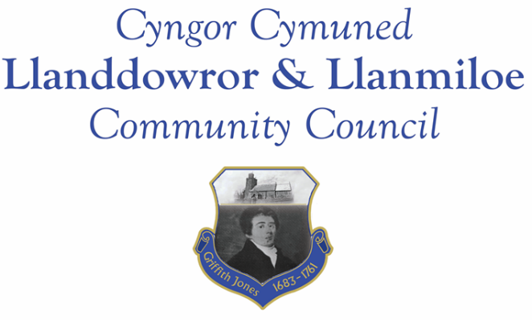

Minutes of the normal meeting of Llanddowror and Llanmiloe Community Council
Held Monday 3rd October 2022.

Present Cllrs Terence Langdon (meeting Chairman), Phill Pickersgill, Gwyn Owen, David Howells, Eric Haines, County Cllr Jane Tremlett and two members of the public.
- Apologies. There were apologies received from Nigel Hodson and Sandra Hewens
- Declarations of personal interests. No interests were declared.
- Questions from members of the public regarding agenda items. Members of the public raised their ongoing concerns regarding the existing planning enforcement case in Llanddowror and their related concerns regarding speeding traffic through the village. Both items had been previously raised a number of times by the Council with CCC and GoSafe. The concerns were noted.
- Adoption of previous minutes for the Annual Meeting and normal meeting on 13th June and 18th August 2022. These were agreed by all, and duly signed by the Chairman.
- County Councillor’s report: County Cllr Tremlett provided an update from CCC officers regarding the various traffic speed related concerns that had been raised: in summary the speed signage in Llanmiloe was sufficient for purpose, with signs placed both sides of the road and made of suitably reflective material and lit so that it was visible night and day. The road markings had been refreshed during the summer. The Council could potentially request the existing speed cushions be replaced with round ones – this would be considered in the October meeting.
The other matters such as village entrance picket gates and flashing warning signs it was stated had elsewhere been funded by a grant that was no longer available. For the future decisions on such speed reduction measures by CCC would be after the new 20mph legislation came into effect – the consultation in that was due this year but no dates had been yet announced.
It was agreed that both the Council and Cllr Tremlett would write to the Chief Constable to raise the ongoing speeding concerns. The Council’s letter to the Police and Crime Commissioner highlighting the issues in June had resulted in contact being established with the relevant GoSafe Sergeant.
- Clerk’s report. The Clerk had previously circulated the report and provided verbal updates on the various matters. These included that the Coastal Path shrubbery had been cut back in the early summer improving access and visibility, although the waste material had not been removed from site; the ownership of the Dan y Bryn land strip had been established. It was stated that there was a lot of action being undertaken behind the scenes by the Council.
- Matters ongoing from previous minutes:
- Community projects: The A4066 pill clearance would not be undertaken by this Council for various reasons as agreed in the August meeting. However after a site meeting in September the relevant Officers in CCC were pushing for the work to be done by the legal land owners – the MoD.
- It was agreed that the Council could in principle provide equal match-funding to both community associations to support the provision of new play equipment - the Clerk would contact the two bodies accordingly.
- The meeting was informed that the contractors would be undertaking the Llanddowror Pocket Park tree work soon.
- Llanddowror Old Café site. This had been extensively discussed during the public participation section of the meeting. It was agreed that it was an ongoing concern, and progress by the enforcement officers had not been as expected. Cllr Tremlett would arrange a site meeting with the relevant Officers, Community Cllrs and members of the public to hopefully bring the matter to a suitable resolution quickly.
- Council vacancies. Cllrs would continue to seek suitable candidates.
- New business:
- Council training policy. This had been previously circulated. After a brief discussion it was agreed to adopt it.
- An application to the Safer Routes in Communities had been made during the summer. This was not being taken forward by CCC, but was praised for its quality. Should the opportunity arise again the Council would certainly consider making another application
- Llanmiloe School Governor vacancy. The Clerk had been contacted by CCC stating that a potential parent candidate for the role had been identified. No update had been provided – the Clerk would chase this up.
- Llanddowror seat – it was agreed that the old rusty seat at the end of the village needed replacing. Costs obtained including obtaining the relevant streetwork licences (as well as considering health and safety) indicated that the work would be most cost effectively undertaken by CCC themselves. This was agreed.
- Remembrance wreaths. After a brief discussion it was agreed to purchase two wreaths. Cllr Langdon would attend the Llanmiloe serviced and probably Cllr Haines the Llanddowror/St Clears one – that to be confirmed nearer the time.
- Llanddowror sandbag containers. It was stated that the one in the Pocket Park was rusty and dangerous. It was agreed to request CCC replace that one with a new one, located adjacent to the Meeting Room so that it was more easily accessible. It was also agreed to request non-biodegradable sandbags so that they did not disintegrate when picked up. Cllr Tremlett would put in these requests.
- Llanddowror Meeting Room. The Council was pleased that the minor leak had been repaired so promptly. It was agreed to trial keeping the toilets open all year around, after multiple reports that they were being well used by local residents as well as visitors to the area. The Council discussed a donation box idea to contribute towards the upkeep, which it was agreed to trial.
- Review of the Financial Regulations. These had been previously circulated. It was agreed to amend the regulations regarding the financial limits for contracts.
- Clerk laptop. A report for information had been provided to all Cllrs. It was agreed the Clerk should purchase a replacement laptop of a good specification, and also the relevant software requested. A guide maximum price of £1000 was stated.
9. Financial Report
The current financial situation was provided to all Cllrs.
- Income received: £4166.67 - this being the second installment of the precept.
- Invoices to pay:
- Clerk monthly salary and expenses – July, August, September. The July and August payments have already been made as per contract but were noted for information.
- BLC – toilet cleaning June, July, August, September- £80.00, £64.00, £64.00, £102.49. Note – as agreed in June 2022 these contracted payments have been made and are noted for information.
- HMRC monthly payments – July, August, September. The July and August payments have already been made as per contract but are noted for information.
- Dwr Cymru - £20.50 (direct debit) per month.
- Swalec - £36.23 on 29-7-22 – direct debit.
- One Voice Wales membership - £137.00.
- Royal British Legion - £50.00 donation towards wreaths.

10. Significant correspondence.
- One Voice Wales training opportunities.
- Welsh Govt – fairer Council Tax consultation – open until 4-10-22.
- Welsh Government – legislation on speed limit changes, starting 2023.
- Correspondence regarding A477 Red Roses junction – for information.
- Invitation to St Clears RBL 85 years exhibition. It was agreed that Cllr Hewens would attend if possible – otherwise Cllr Haines or Howells would attend.
s
11. Planning matters.
PL/04407 - Proposed new 3 storey residential dwelling development - Plot 5, Land adjoining Wood End, Dan Y Bryn, SA33 4UG. Application registered 04-08-2022. The Council raised objections that a three storey structure was not in keeping with the rest of the development, or the area. In addition it could interfere with others’ privacy or visual manenity. It also potentally set a precedent for other applications.
PL/04502 - Construction of house - 14 Dan Y Bryn, Pendine, Carmarthen, SA33 4EZ Application registered 12-09-22.
PL/04456 - Proposed erection of a single new dwelling on an existing residential development - Land Adjacent to Wood End/Dukes Meadow, Pendine, Carmarthen, SA33 4UG. Application registered 13-09-2022.
PL/04094 - Extension to dwelling house with link to form additional bedroom - Honeywell Barn, Laugharne, Carmarthen, SA33 4RA. Consultation from 31-5-22. Application granted 19-07-2022.
PL/04215 - Proposed demolition of conservatory and creation of new sun room - Parc Cynog, Laugharne, Carmarthen, SA33 4PY Application registered 16-06-2022. Application granted 27-07-2022.
No planning was received prior to meeting but after the date of publication of this agenda.
12. Councillors’ reports for information or items for next meeting.
13. Date of next meeting – 14th November 2022.
There being no further business the meeting concluded at 8.50pm

