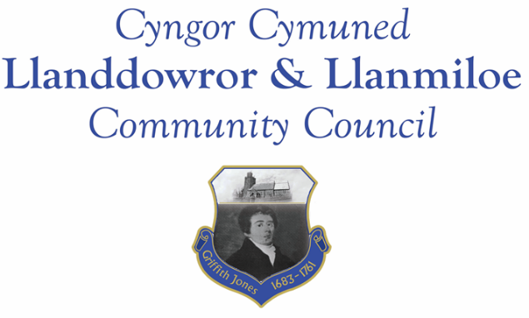

Equal Opportunities Policy

Llanddowror and Llanmiloe Community Council will not discriminate against any individual on the following grounds:
- Age
- Disability
- Gender reassignment
- Marriage and civil partnership
- Pregnancy or maternity
- Race including colour, nationality and ethnic or national origin
- Religion or belief
- Sex (gender)
- Sexual orientation
These are the protected characteristics under the Equality Act 2010.
The purpose of this policy is to ensure that the council provides opportunities to all employees, irrespective of whether any of the above characteristics applies, unless there is a genuine occupational qualification or objectively justified reason for a different approach to be taken. Llanddowror and Llanmiloe Community Council opposes all forms of unlawful and unfair discrimination whether it be direct or indirect discrimination, victimisation or harassment on the grounds of the protected characteristics defined in the Equality Act 2010.
All employees whether full-time, part-time, fixed term contract, agency workers or temporary staff will be treated fairly and equally. Selection for employment, promotion, training, remuneration and any other benefit will be on the basis of aptitude and ability. All employees will be helped and encouraged to develop their full potential and the talents and resources of the workforce will be fully utilised to maximise the efficiency of the Community Council.
Every employee is entitled to a working environment that promotes dignity and respect to all. No form of intimidation, bullying or harassment will be tolerated. This is included in the Dignity at Work Policy adopted by the council.
Breaches of this Equal Opportunities Policy will be regarded as serious misconduct and could lead to disciplinary proceedings. Employees are entitled to complain about discrimination, harassment or victimisation through the Council’s Grievance Procedure.
January 2018

