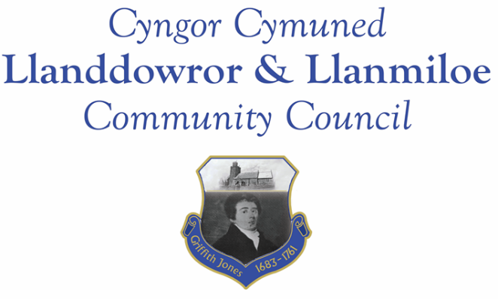
Minutes of the normal meeting of Llanddowror and Llanmiloe Community Council
Held in the various locations via Zoom, Monday 8th November 2021.

Present Cllrs David Howells (Chairman), Terence Langdon, Sandra Hewens, Nigel Hodson, Gwyn Owen, Phill Pickersgill, and a member of the public.
Apologies. These were received from Cllrs Chris Holt and County Cllr Jane Tremlett.
Declarations of personal interests. No interests were declared..
Adoption of previous minutes. The minutes of the meeting of 11th October had been previously circulated. The minutes were accepted as a true record, and so the minutes would be duly signed at the earliest opportunity.
County Cllr’s report. County Cllr Tremlett was on extended compassionate leave after the deaths of close family members. The Council expressed their sympathies to her. It was agreed that Cllr Howells would attend the funeral to represent this Council, and that a donation would be made to the nominated recipient – the Coronary Care Unit at Glangwili Hospital.
Matters ongoing from previous minutes:
- Meeting Room water channel and door. The agreed contractor had been contacted by Cllr Hodson but the channel had not yet been done. Cllr Howells had subsequently contacted a local contractor regarding both this and the Meeting Room door, and quotations for both issues would be provided to the Clerk, who would also seek other quotations for the door. It was stressed that the door was now a safety risk for any potential user so urgent action was required.
- Councillor vacancies. The potential North Ward Councillor was introduced and considered by those present. All were happy to have him join the Council, and so Eric Haines was voted on and welcomed onto the Council. The Clerk would complete the administrative requirements as soon as possible.
- Flooding issues in Llanmiloe. The Council were still awaiting a full response from Carmarthenshire. The Clerk would chase up.
- Meeting Room. The water supply issue had been a leaking valve, which had been replaced. The door had been discussed in an earlier item. The jazz band no longer wished to use the premises because it was too small for their needs.
- Llanmiloe noticeboard. This would be checked and repaired or replaced in the near future.
- Meeting Room wifi. The Clerk reported that LEADER could only fund equipment, not wifi installation or provision. She was looking further into how this might be achieved and would report back to Council as soon as possible.
New business:
- Llanmiloe School Additional Community Governor. Cllr Holt had held this role for two years. This was discussed, and it was felt he should be consulted as to whether he wished to continue, and also Pendine and Eglwyscummin Councils should be asked if they were putting forward candidates. The Clerk would make these enquiries.
- Carmarthenshire County Council toybox appeal. This was discussed, and it was agreed to make a donation.
- Llanmiloe – resurfacing work issues. The Clerk summarised the situation: the contractors during the recent work had based themselves on private property without permission. This had been resolved and apologies received from them.
- Llanmiloe – antisocial behaviour. The Clerk summarised the ongoing situation and concerns. A meeting with the police was planned for the near future. After discussion it was agreed to provide clear guidance for residents on how to report incidents as well as pushing for the situation to be resolved as quickly as possible, and to contact the local police Beat Manager as well as see whether there could be greater police presence put into the community.
Financial report:
An up to date report on the finances of the Council had been previously circulated, and was discussed.
The following invoices were noted, and agreed for payment by all:
- Clerk monthly salary and expenses - November.
- Clerk monthly tax due – November.
- Dwr Cymru direct debit £16.50 monthly
- Swalec – quarterly direct debit - £39.90
- Danfo – toilet cleaning October - £84.00
- Taf Building Supplies – replacement valve for MR toilet - £15.54 – see above item.
- Hywel Dda Health Charities – donation - £30.00 – see above item.
- CCC toybox appeal - £75.00 – see above item.
Significant correspondence
- One Voice Wales training opportunities.
- Royal British Legion – St Clears Branch – thank you letter for donation.

Planning matters:
There were no new planning application or decisions to bring to the attention of the Council.

Councillors’ reports for next meeting.
Cllr Hewens stated that the light near the school had still not been repaired – the clerk would chase up on that. Cllr Hewens also stated that two trees along the Llanmiloe main road had been blown down in the recent gales – the Clerk would report these to CCC for removal by them. In addition the temporary drain cover adjacent to 118 Llanmiloe was still in place – a permanent repair was required. The Clerk would chase up on this.
Cllr Howells stated that he and other Councillors were receiving complaints from local residents about the lack of action by CCC especially over issues raised.
Date and venue of next meeting
The next meeting was planned for December 13th, most probably via Zoom.
There being no further business the meeting concluded at 8.00pm.

