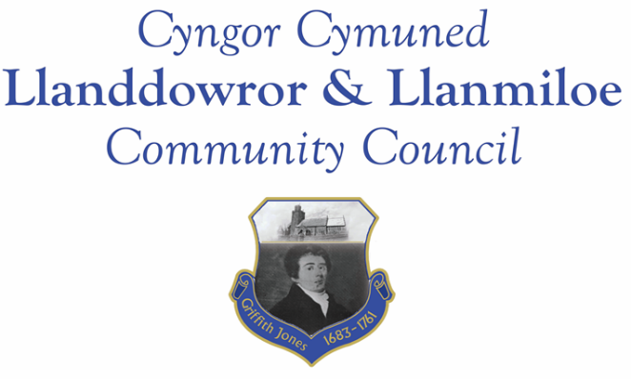
Minutes of the normal meeting of Llanddowror and Llanmiloe Community Council
Held in the various locations via Zoom, Monday 16th November 2020.

Present Cllrs Terence Langdon, Gwyn Owen, Phill Pickersgill, Sandra Hewens, Nigel Hodson, David Howells and County Cllr Jane Tremlett.
Apologies. These were received from Cllr Chris Holt, and his reasons for absence were accepted. All those present wholeheartedly wished him well.
Declarations of personal interests. There were none received.
Adoption of previous minutes. The minutes of the meeting of 12th October had been previously circulated. The minutes were accepted as a true record and would be duly signed at the earliest opportunity – proposed Cllr Hewens, seconded Cllr Howells and agreed by all.
Cllr Hewens, who had been having technical difficulties, joined the meeting at this point.
County Cllr’s report. County Cllr Tremlett stated she had raised the resurfacing of the whole stretch of road that ran through Llanmiloe as far as she could, pointing out the very public negative impact that a substandard road would have upon the Pendine Tourist Attractor Project.
Correspondence regarding the speed checks that had been done two years ago had been forwarded on the day of the meeting. This was briefly discussed, and it was agreed that it should be considered by the local residents regarding what methods they would be happy supporting to manage the speed of traffic if they were possible. This would be brought back to the Council next month.
Cllr Tremlett was asked for an update on the provision of a bottle bank in the layby in Llanddowror – she would chase up on that request from September.
The sleeping policeman near the turn down to Llanmiloe shops was raised again – the signage currently does not clearly notify drivers that a ramp is there, especially now when more drivers are traveling in the dark. Cllr Tremlett would find out whether more warning signs could be located there.
There being no other matters for the County Councillor, she left the meeting.
Matters ongoing from previous minutes:
- Meeting Room water channel. The contractor had responded, and stated it would be done very soon - the Clerk continue to chase to get the work done.
- Appointment of Vice-Chairman. After discussion Cllr Hewens was nominated to this position. All present agreed and so she was appointed.
- Councillor vacancies. The meeting was reminded of the current vacancies, and potential candidates would continue to be sought.
- Llanddowror bottle bank trial. This had been discussed earlier in the meeting.
- Community activities by the Council. The Clerk reported that the seats for Llanddowror Pocket Park were on order. Discussions were held on what else might be appreciated, and ideas would be taken back for consideration by Llanmiloe and District Community Association.
New business:
There was no new business that had been placed before the Council for consideration.
Financial report:
An up to date report on the finances of the Council had been previously circulated.
The following invoices were noted, and agreed for payment – proposed by Cllr Howells, seconded by Cllr Owen and agreed by all:
- Clerk monthly salary and expenses.
- Clerk monthly tax due.
- Dwr Cymru direct debit £13.50 monthly
- Swalec direct debit quarterly £87.32
- Danfo – toilet cleaning contract - £84.00 for October
Correspondence
Items of correspondence since the last meeting had been forwarded upon receipt. Specific items to note were:
- Welsh Govt consultation on draft regulations for 4 regional Corporate Joint Committees in Wales.
- Welsh Govt consutation on Strategic Development Plans for use by the CJCs mentnioed above.
- Welsh Govt National Strategy for flood and coastal erosion risk management in Wales.
- One Voice Wales remote training opportunities in November.
- Electoral Reform newsletter.
- Welsh Govt draft statutory guidance for principal councils consultation in light of Local Government and Elections (Wales) Bill.
- Dyfed Powys Police phone call scam warning.
- Welsh Govt TAN15 flooding revision information.
Planning matters:
No planning applications or decisions had been received since the last meeting.
Councillors’ reports for next meeting.
There were no issues raised.
Date and venue of next meeting
The next meeting was planned for 14th December, most probably via Zoom. The Clerk would call a meeting beforehand if it was required.
There being no further business the meeting concluded at 8.00pm.

