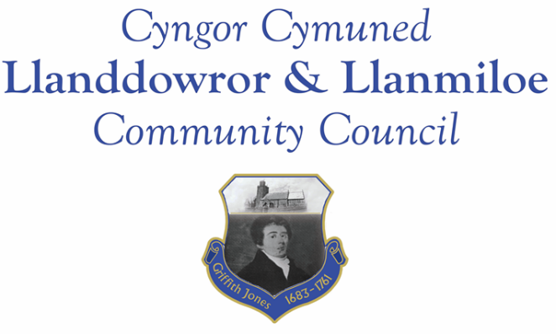

NOTICE OF MEETING

To All Members of Llanddowror & Llanmiloe Community Council.
I hereby summon you to attend the meeting of the Council, starting at 7.00pm on Monday 13th February 2023, for the transaction of the business outlined in the agenda below.
This meeting will be held in Llanmiloe Resource Centre unless Zoom access is requested.

Vicky Mitchell – Clerk

Agenda

1. Apologies for absence.

2. Declaration of personal and prejudicial interests.

3. Questions from members of the public regarding items on the agenda.

4. Adoption of previous minutes of meeting held on 9th January 2023.

5. County Councillor’s report, including on matters raised in previous meetings, specifically:
Sandbag containers and bag provision; update on Llanddowror enforcement issue.

6. Clerk’s report.

7. Matters ongoing from previous minutes requiring discussions or decisions, not covered above:
- Community projects – receive any new information on specific projects – those agreed were: working with both community associations to provide play equipment in both communities, Llanddowror Pocket Park tree management.
- Llanddowror Old Café site – consider any recent information received on planning application or enforcement process and agree any next steps to take that are available to this Council.
- Receive any feedback on Llanddowror Meeting Room donations box.
- Consider provision of donation to Llanmiloe School PTA to assist with costs of goalposts and bike racks.
- Receive update on water leak in Meeting Room disabled toilet – agree any next steps needed.

8. New business.

- Consider dates for April and May meetings: Easter Monday is 10th April, Coronation Bank Holiday is Monday 8th May. Decide a new dates if agreed that is worthwhile.
- Consider Llanmiloe School – Additional Community Governor nomination – nominee does not need to be a Cllr.
- Consider consultation on proposed 30mph to 20mph changes.
9. Financial Report
- Current financial situation: Financial report appended to agenda.
- Income received: None since last meeting.
- Invoices to pay:
- Clerk monthly salary and expenses – February.
- HMRC monthly payments – February.
- Dwr Cymru - £20.50 (direct debit) per month.
- Swalec – 4th quarter - £39.56 (direct debit) – paid late January
- BLC – toilet cleaning February - £64.00
- Davies Y Gwres – Plumbing work - £175.00 (maintenance/MR)
- Chris Thomas – repair work MR - £100.00 (maintenance/MR)
- Zurich – council insurance - £586.31
- Birch Utility Services – Llanddowror Pocket Park tree work - £540.00 (community project)

10. Significant correspondence.
- One Voice Wales training opportunities.

Any other correspondence received prior to meeting but after the date of publication of this agenda will be brought to the attention of the meeting for consideration.

11. Planning matters.

PL/05154 - Retrospective change of use of a cafe car park to an enclosed yard to house rescue dogs including the retention of storage containers and a 2.1m high security fence. Dan y Pound Cottage, Llanddowror. SA33 4HJ. Application registered 14/12/2022. Decision date 31-1-23 – no decision yet made (6-2-23).

Pl/05356 - Lawful development - outbuilding bedrooms. Picton House Hotel. Llanddowror. SA33 4HJ. Application registered 26-01-2023.

PL/05275 - One Planet Development including workshops, stable and polytunnels - Wij Wood, Four Wheels, St Clears, Carmarthen, SA33 4HD. Application registered 11-01-2023.

PL/04972 - Proposed erection of a single new dwelling on an existing and on-going residential development site - Plot 9, land adj to Wood End, Llanmiloe, Pendine, SA33 4EZ. Application registered 1-11-2022. Application full granted 19-01-2023.

PL/05172 - Proposed erection of a single new dwelling on an existing residential development. Plot 4, Dan Y Bryn, Pendine, SA33 4UG.Application registered 8/12/2022. Application full granted 20-01-2023.

PL/05282 - Conversion of integral garage. Woodside, Brook, Laugharne, Carmarthen, SA33 4NX. Application registered 9-01-2023. CLOPUD approval 20-1-2023.

PL/00027 - Improvement to access and creation of turning and loading area in association with forestry management. Parciau Forestry, Llanddowror. Application valid 11-9-2020. Application full granted 26-01-2023.

Any planning received prior to meeting but after the date of publication of this agenda will be brought to the attention of the meeting for consideration.

12. Councillors’ reports for information or items for next meeting.

13. Date of next meeting – 13th March 2023.

~~~~~~~~~~~~~~~~~~~~~~~~~~~~~~~~~~~~~~~~~~~~~~~~~~~~~~~~~~~~~~~~~~~~~~~~~~

Meeting dates for 2023:

March 13th 2023 April 10th 2023 tbc
May 8th 2023 tbc 12th June 2023
11th September 2023 9th October 2023
13th November 2023 11th December 2023
Meetings to be either in Llanmiloe Resource Centre, with hybrid access via Zoom provided as required, or in Llanddowror Meeting Room, or via fully Zoom.

